IBM UrbanCode Deploy NewRelic Plug-in
Overview

This NewRelic plug-in enables you to post deployment notifications of specific component and it’s version to NewRelic.

The plug-in step enables you to configure NewRelic Deployemnt notifications from UrbanCode Deploy by populating the required fields when defining the process (located under: Notifications > NewRelic > Deployment Notification):
- Name*
- NewRelic URL* (seehttps://docs.newrelic.com/docs/apm/new-relic-apm/maintenance/deployment-notifications)
- NewRelic API key*
- User* ( default: UrbanCode-Deploy )
- Application Name* ( default-${p:component.name} ) hidden
- Version* ( default-${p:version.name} ) hidden

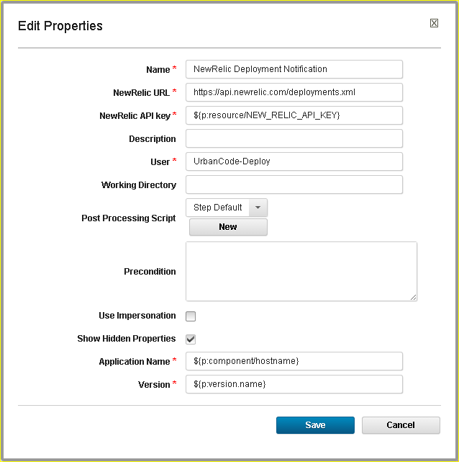

Usage

This section elaborates on the procedure to be followed to use this plug-in.
Before you begin
- Installed and started your UrbanCode Deploy Server, you can refer to
http://coltrane-new.rtp.raleigh.ibm.com/ucdeploy/index.jsp
- Installed Started the UrbanCode Deploy Agent which connects to the UrbanCode Deploy Server
- Load the NewRelic plug-in into the UrbanCode Deploy Server.

